Customer Journey Map
Metro Ticket Generating System in ServiceNow
Date | 5 September 2026
Project ID | SWUID2026190359
Project Name | Metro Ticket Generating System in ServiceNow
Scenario
Booking, paying for, and receiving a digital metro ticket through the ServiceNow Service Portal.
Journey Architecture / Stages
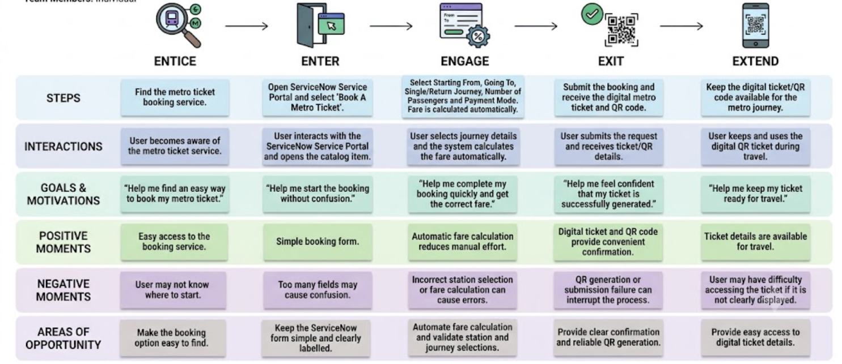

Entice | Enter | Engage | Exit | Extend
Become aware of the metro ticket booking service | Open the ServiceNow Service Portal and start booking | Enter journey details, calculate fare and choose payment mode | Submit the request and receive the digital ticket / QR code | Use the ticket for travel and refer to the booking details later

Journey Dimension | Entice | Enter | Engage | Exit | Extend
STEPS | Find the metro ticket service | Open ServiceNow Service Portal and select Book A Metro Ticket | Select Starting From, Going To, journey type, passengers and payment mode | Submit booking and view generated ticket / QR code | Keep the digital ticket/QR code for the journey
INTERACTIONS | Sees or is informed about the ticket booking service | Interacts with the ServiceNow catalog item | Selects stations and options; system automatically calculates fare | Confirms/submits the request and receives ticket details | Uses the QR ticket as the digital representation of the booking
GOALS & MOTIVATIONS | Help me find an easy way to book my metro ticket | Help me start the booking without confusion | Help me complete booking quickly and get the correct fare | Help me feel confident that my ticket is successfully generated | Help me keep my ticket ready for travel
POSITIVE MOMENTS | Easy access to the booking service | Simple form with required journey fields | Automatic fare calculation reduces manual effort | Digital ticket and QR code provide convenient confirmation | Ticket details can be referred to when needed
NEGATIVE MOMENTS | User may not know where to start | Too many fields can cause confusion | Incorrect station selection or fare logic can cause errors | QR generation or submission failure can interrupt the process | User may have difficulty accessing the ticket if it is not clearly displayed

